FOR IMMEDIATE RELEASE DATE: 6/3/2020
CONTACT: Juan L. Babauta (CCA Executive Director)
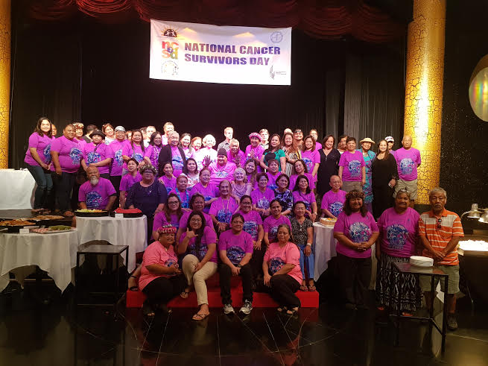
CNMI Cancer Survivors Day-1st Sunday, June 7, 2020

Sunday, June 7, 2020, marks the 9th annual CNMI Cancer Survivors Day® Celebration of Life - the day set aside each year to recognize cancer survivors, raise awareness of the ongoing challenges cancer survivors face because of their disease, and celebrate life.
With nearly 17 million people living with and beyond cancer in the U.S. today - and more than 43 million cancer survivors worldwide - everyone knows someone whose life has been touched by cancer. On Sunday, June 7, 2020, people around the world are coming together to acknowledge these cancer survivors, and to raise awareness of the challenges of cancer survivorship, as part of the 33rd annual National Cancer Survivors Day®.
According to the Commonwealth Cancer Association (CCA), Executive Director Juan Babauta, "A 'survivor' is anyone living with a history of cancer - from the moment of diagnosis through the remainder of life."
"When people hear the words 'you have cancer,' it can be very frightening," says CCA Board President Bo Palacios. "But there is HOPE. Today's cancer survivors are living longer, better quality lives than ever before. Commonwealth Cancer Survivors Day® gives our survivors - and those who support them - a special day each year to celebrate life and to show the world that you can have a good life after a cancer diagnosis.
"CCA is also a call to action. Cancer survivors face ongoing, often long-lasting, hardships because of their disease. On Commonwealth Cancer Survivors Day®, we want to raise awareness of the many challenges of cancer survivorship and advocate for further research, more resources, and increased public awareness to improve the lives of cancer survivors."
“Everyone with cancer, who’s had cancer in the past, or who knows someone with cancer should have hope,” says CCHC medical oncologist Dr. Peter Brett. Although not everyone with cancer can be cured, with today’s care most people with cancer will have an improved quality of life and length of life, and will have a better chance of staying well for longer. With improved treatments, many people who have had cancer will never have it recur or come back. It’s always important to pay attention to healthy behaviors that can help, too, like regular exercise and a healthy diet.”
The CCA is encouraging everyone - cancer survivors, caregivers, healthcare professionals, family members, and friends - to join the celebration.
Due to COVID-19, many of the public events scheduled to celebrate CNMI Cancer Survivors Day® have been canceled. However, that doesn't mean that the celebration is canceled. You can connect with cancer survivors and supporters around the islands on Sunday, June 7, by connecting to the CNMI Cancer Survivors Day® site on Facebook (Facebook.com/CancerSurvivorsDay), or Website (www.ccamarianas.org)
The nonprofit Commonwealth Cancer Association offers free guidance, education, networking resources, and assistance to the CHCC Oncology Center, and to support groups, and other cancer-related organizations that host official CNMI Cancer Survivors Day® celebrations. The CCA mission is to bring awareness to the issues of cancer survivorship in order to better the quality of life for cancer survivors.
As the number of cancer survivors continues to grow, it is becoming ever more important to address the unique needs of this population. In addition to facing a serious illness, cancer survivors must contend with rapidly rising drug costs, inadequate insurance coverage, difficulty finding or keeping employment, and ongoing physical, psychological, and financial struggles that persist even after treatment ends.
In 2003, the CCA began as an alliance of volunteers, becoming formally chartered and incorporated in 2008. In 2009 the CCA achieved a tax-exempt status under 501 (c)(3), and since then has provided direct financial assistance, assistance with nutritional supplements and other personal needs, as well as, certain types of medical equipment such as hospital beds, wheelchairs, and oxygen concentrators prescribed by a locally licensed physicians to qualifying clients in the CNMI who are receiving treatment for cancer.
The CCA also facilitates monthly cancer survivors and caregiver support group meetings, engages in a variety of awareness and outreach activities, and has produced various educational publications such as brochures, fliers, Video’s and DVD’s for our diverse community. Awareness activities and events related to cervical cancer, oral cancer, colorectal cancer, breast cancer, prostate cancer, and lung & pancreatic cancer awareness, are just a few of the annual calendar of educational and outreach activities carried out by the CCA. The CCA also engages in programs such as early screening and detection, and patient navigation. The CCA has formed critical partnerships with all seven of the CNMI’s dental clinics, in order to enable FREE Oral Cancer Screenings for all ages.
The CCA extends thanks to all of its partners, donors and individuals who contribute to the successful programs of the CCA. The public is encouraged to learn about our programs and contribute to the very important and worthwhile work of the association. For more information, you can contact the CCA at telephone 682-0050 or via email at ccamarianas@gmail.com, or visit our website at www.ccamarianas.org///

